Writing 1 hour
TASK 01:
You should spend about 20 minutes on this task.

The diagram below shows how potato chips are made. Summarize the information by selecting and reporting the main features, and make comparisons where relevant.

Write at least 150 words.
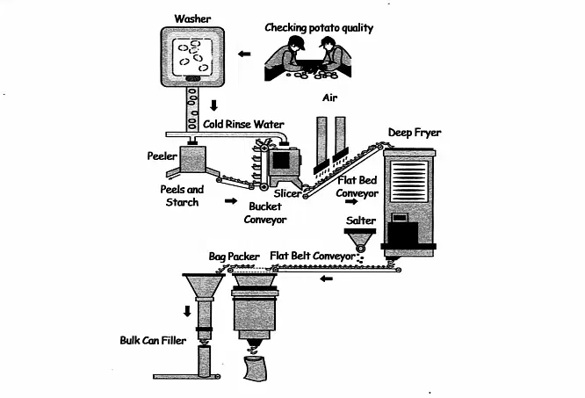
TASK 02:
You should spend about 40 minutes on this task.

What can individuals do to improve their mental health, and what steps can society take to reduce the stigma around mental illness and provide better support for those who are struggling?
Write at least 250 words.
Writing 1 HOUR
TASK 01:
You should spend about 20 minutes on this task.

You recently booked a part-time course at a college. You now need to cancel your booking.
Write a letter to the college administrator. In your letter,
- say which part-time course you booked
- explain why you need to cancel your booking
- ask about booking a different course

Write at least 150 words.
You do NOT need to write any addresses.

Begin your letter as follows:
Dear Sir or Madam,

TASK 02:
You should spend about 40 minutes on this task.

What can individuals do to improve their mental health, and what steps can society take to reduce the stigma around mental illness and provide better support for those who are struggling?
Write at least 250 words.

